|  |  |
| --- | --- |
| Whitireia Logo_2010 | **Faculty of Business and Information Technology** |

**Certificate in Information Technology**

**IT5x83 Fundamentals of**

**Software Design and Development**

**Assignment Proposal**

**Author:** Taylor Everett

**STU ID:** 21600252

**Date Due:** 17/10/2016

**Table of Contents**

[**Executive Summary** 3](#_Toc464404327)

[**Introduction** 3](#_Toc464404328)

[**Design Methodology** 4](#_Toc464404329)

[JAD “Joint Application Development” 4](#_Toc464404330)

[RAD “Rapid Application Development” 4](#_Toc464404331)

[Agile Software Development Methodology 4](#_Toc464404332)

[**Development Strategy** 5](#_Toc464404333)

[**Site MAP** 6](#_Toc464404334)

[**Wireframe** 6](#_Toc464404335)

[**Systems Requirements Checklist** 8](#_Toc464404337)

[**USE case diagram** 10](#_Toc464404338)

[**Logic Depiction Diagram** 10](#_Toc464404339)

[**Conclusion** 11](#_Toc464404341)

[**References** 11](#_Toc464404342)

# Executive Summary

In this proposal, the project “Dream Getaways Resort” website will be introduced in its entirety to our understanding. The listing of design methodology for the website build through pros and cons between three different software design methodologies JAD, RAD and Agile methodology, we used JAD. Next would be our choice in development strategy of in-house and why. Site map, wire frames, system requirements checklist, Use-case diagram, and Logic depiction diagram are provided to show our design and function of all who are involved for the website.

# Introduction

Dream Getaways is a tourism business who owns a resort running a manual check-in and experience system using forms and would like a website for the business that involves a booking systems for customers checking into their resort hotel. The new system should cater when customers intend to arrive and how long they will be staying as well as the types of rooms they will be staying in such as single, shared or double room sizes.

Have received a permission from Dream Getaways Resort that we will design and create a website to promote the company’s activities. The new system will also allow the customers to organise their experience plans such as attending biking, hiking and canoeing events as well as tending to departure plans of their customers providing shuttle services where required. Initially we have produced a preliminary Investigation Report and determined that Dream Getaways Resort request is feasible and can set out some initial project planning requirements.

# Design Methodology

Of the design methodologies we use for this Project we have chosen “JAD” and listed below are the three we use along with their pros and cons by Jamsheer (2016).

“

## JAD “Joint Application Development”

* **Pros**
  + Allows for simultaneous congregation and alliance of excessive information.
  + Produces huge amount of valuable information in short period
  + Immediate resolving of differences with suitable assistance
  + Provides forum to explore multiple points
* **Cons**
  + Takes excessive amount of time for planning and scheduling
  + Requires significant investment of time and effort
  + Calls for highly trained experts, which is tough to find

## RAD “Rapid Application Development”

* **Pros**
  + Makes the entire development process effortless
  + Assists client in taking quick reviews
  + Encourages feedback from customers for improvement
* **Cons**
  + Dependent on the team for performance
  + Works on modularized system confined on this methodology
  + Requires extremely skilled personnel to handle complexities
  + Not applicable for the small budgeted projects

## Agile Software Development Methodology

* **Pros**
  + Adaptive approach that responds to changes favorably
  + Allows for direct communication to maintain transparency
  + Improved quality by finding and fixing defects quickly and identifying expectation mismatches early.
* **Cons**
  + Focuses on working with software and lacks documentation efficiency
  + Chances of getting off-track as outcome are not clear”

# Development Strategy

We chose to build this website in-house and not to outsource the website for the following reasons.

* Developing Software In-House
  + Satisfy unique business requirements
  + Minimize changes in business procedures and policies
  + Meet constraints of existing systems
  + Meet constraints of existing technology
  + Develop internal resources and capabilities
* Purchasing a Software Package
  + Lower costs
  + Requires less time to implement
  + Proven reliability and performance benchmarks
  + Requires less technical development staff
  + Future upgrades provided by the vendor
  + Input from other companies
* Customizing a Software Package
  + You can purchase a basic package that vendors will customize to suit your needs
  + You can negotiate directly with the software vendor to make enhancements to meet your needs by paying for the changes
  + You can purchase the package and make your own modifications, if this is permissible under the terms of the software license

# Site MAP

Home Page

Booking Page

Restaurant Page

Experience Page

About Page

Contact Page

Payment form

Accommodation form

Experience form

# Wireframe

Home Page

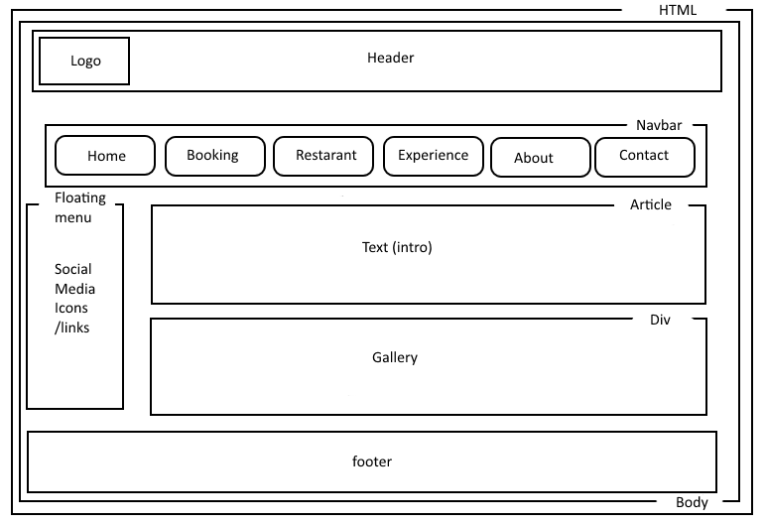

Booking Page

# C:\Users\DeathSythe\Desktop\wfbooking.png

Restaurant, Experience, and About Us Page

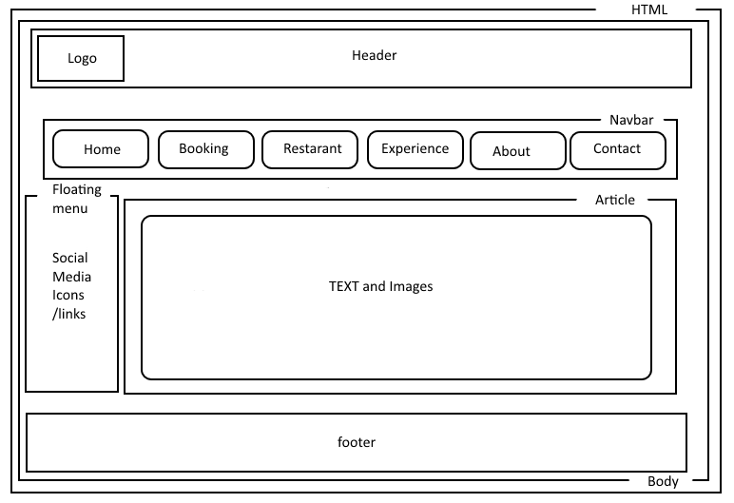

Contact Us Page

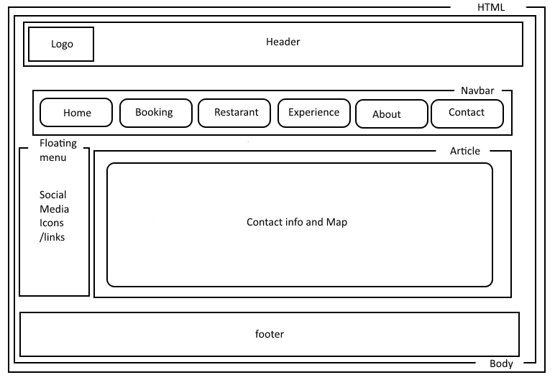

# Systems Requirements Checklist

|  |  |  |  |  |  |  |
| --- | --- | --- | --- | --- | --- | --- |
| **Item** | **Outputs** | **Inputs** | **Processes** | **Performance** | **Control** | **Check** |
| The company name (logo) centred at the top of the page | Show Logo on all pages | n/a | n/a | n/a | n/a |  |
| A navigation bar that provides links to the additional pages | Shows All pages in the form of a button | User click | Takes user to the correct page | Mouse over | Left click on buttons |  |
| Website’s look and feel is consistent (for all pages). | Elements are in the same place on every page | Navigation bar clicking | Format page | n/a | Navigation bar |  |
| Home Page | general overview about the company | Navigation bar | Informative | Show text and pictures | n/a |  |
| About Us Page | detailed  overview about the company | Navigation bar | Informative | Show text and pictures | n/a |  |
| Contact Us Page | Contact info | Navigation bar | Informative | Show map and Text | Left Click on email |  |
| Booking Page | User can input data to make a booking | Navigation bar and form | users information to make booking | Form | Keyboard input and left click |  |
| Restaurant Page | Shows food and pricing | Navigation bar | Informative | Show pictures and price | n/a |  |
| Extras Page | Shows activities and pricing | Navigation bar | Informative | Show pictures and price | n/a |  |
| Pages Use company colours | Show colours | n/a | n/a | n/a | n/a |  |

# USE case diagram

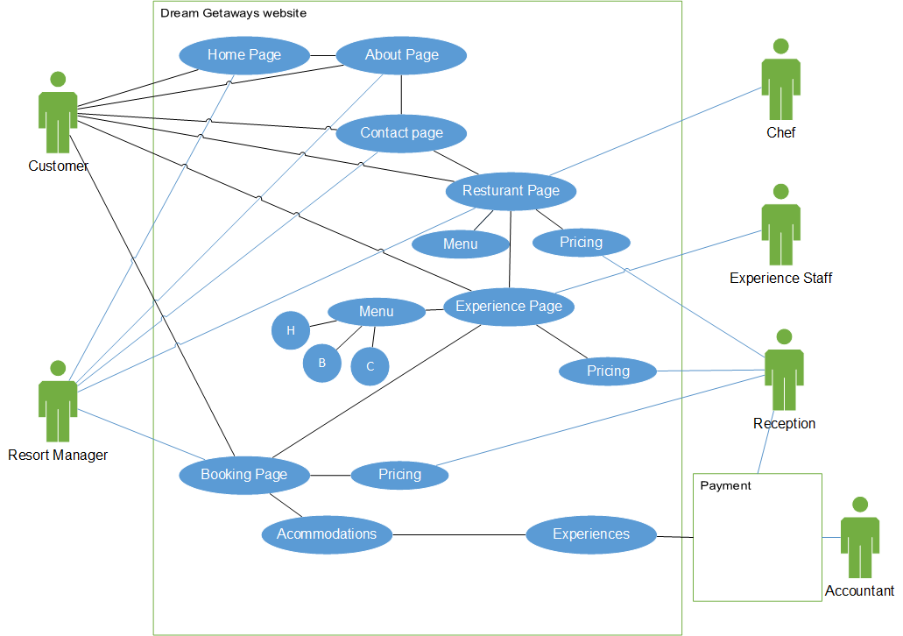

# Logic Depiction Diagram

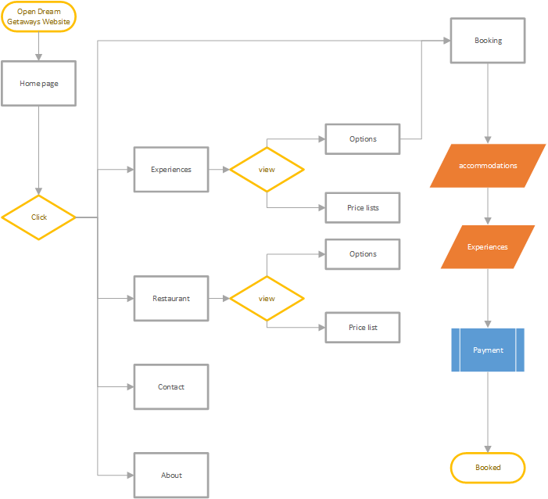

# Conclusion

Dream Getaways Resort is a popular and thriving business who is looking for a way to be number one in its area and their solution is to obtain a website, which I believe we can provide. This would open them up to a new untapped market of ecommerce with a vastly growing population via internet and mobile phones. By having a website, they can lower physical documentation and could even speed up processing time by simplifying their forms to a digital format. This proposal we have determined our design methodology of “JAD” and our development strategy of in-house will be used for the website and have begun to shape it with the wireframe provided. We have included requirements checklist to test that we have provided all the details for content and functions of the website. Through this we have made a Use-case diagram and Logic depiction diagram to show who is using what and how. In conclusion the Dream Getaways website would be a powerful tool to expand Dream Getaways Resort’s present situation as they see fit.

# References

Jamsheer K. (2016). 12 Best Software Development Methodologies with Pros and Cons. Retrieved September 29, 2016, from <http://acodez.in/12-best-software-development-methodologies-pros-cons/>